Project Design Phase-II Customer Journey Map

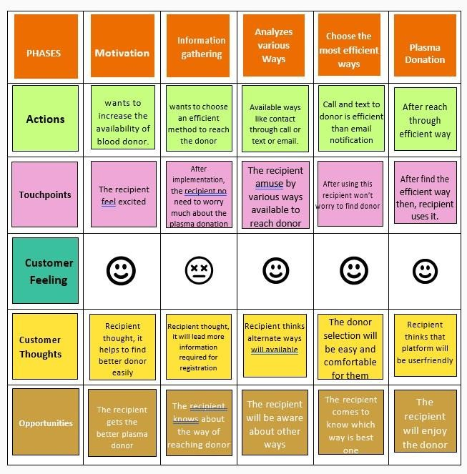

|  |  |
| --- | --- |
| Date | 19 October 2022 |
| Team ID | PNT2022TMID54004 |
| Project Name | Plasma Donor Applications |
| Maximum Marks | 4 Marks |

**Diagram:**